**INSTALLATION GUIDE**

1. This is an installation guide to Photography Website Project. The theme of my project was to create a website for Online Photography Store. Mostly it well well, but I had some difficulty in writing orders to database, also with other things (applying coupon discount at payment/checkout stage, and being able to remove items placed in shopping cart).
2. The Structure of my Photography Online Store is as follows:-

3) The Structure of my website is as follows (see screenshot below):-

(*Please note ‘**module_website.html** is the main page for running and uploading all other web pages. SQL database can be replicated by using the same name (**Web_Apps**) which I used to create this database. I have also included (as per screenshot below) SQL files for this project. The name of the database is Web_Apps. I have exported this, and should be imported.

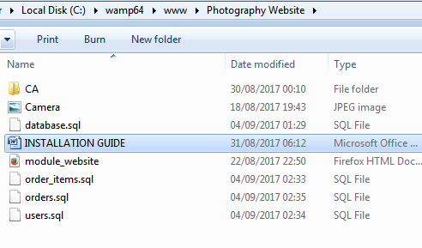

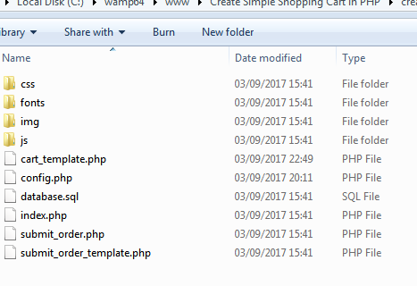

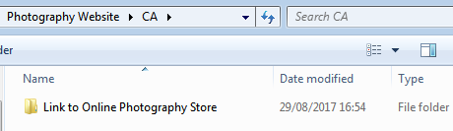

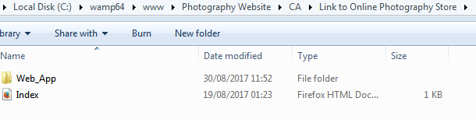

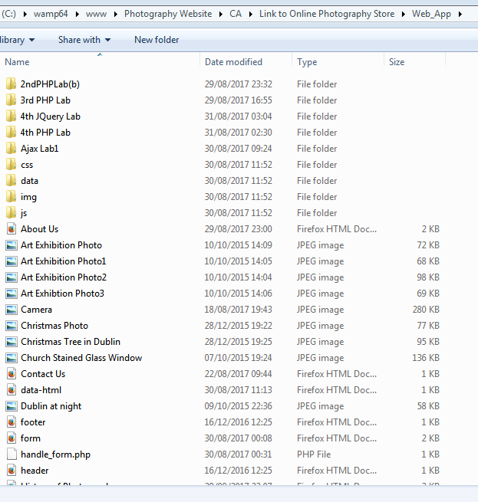

1. Below are the files which are to do with the shopping cart and submitting/checking out – they are all in **Http://Localhost/Photography Website/CA/Link to Online Photography Store/Web_App/4th PHP Lab**/. These are the files I used to base my shopping cart on but have integrated all these files into above (ie) 4th PHP Lab (as this is where the ‘login page’ is for user to log in and be directed to shopping cart).

The website I used to take this shopping cart (php) code from is [http://www.discussdesk.com/create-simple-shopping-cart-with-php-and-mysql.htm. Unfortunately the cart.html](http://www.discussdesk.com/create-simple-shopping-cart-with-php-and-mysql.htm.%20Unfortunately%20the%20cart.html) was omitted from the download code and so I only had cart-template.php, which meant I was unable to remove items and had to physically remove them from the database. Orders were written to database and I have 3 tables (the names of the tables are ORDERS, ORDER-ITEMS, USERS). The database name is web_apps. As the cart.php was missing from the download code, no items can be removed unless via database and items list can’t be viewed on submit page, although items ordered can be viewed. In my SQL files, I’ve listed orders added, however all orders are in the order-items database.



1. Requirements for deploying my projet:-
2. Either have WAMP on your computer or install it.
3. Create database Web_Apps and copy files.
4. Deploy WAMP localhost (http:localhost......) and create new directory.